docker pull hello-world

docker images

docker ps

docker ps -a

docker run nginx

docker run -d -p 8081:80 --name mynginx nginx

docker volume create vol1

volume ls

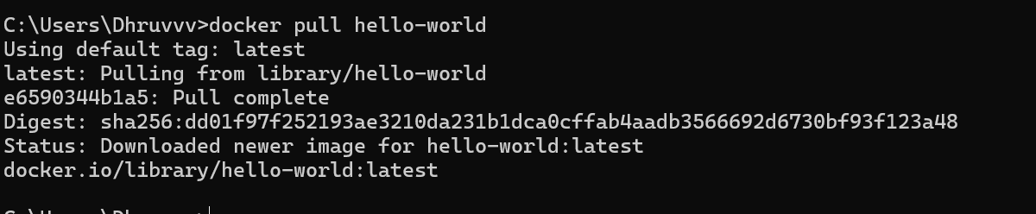

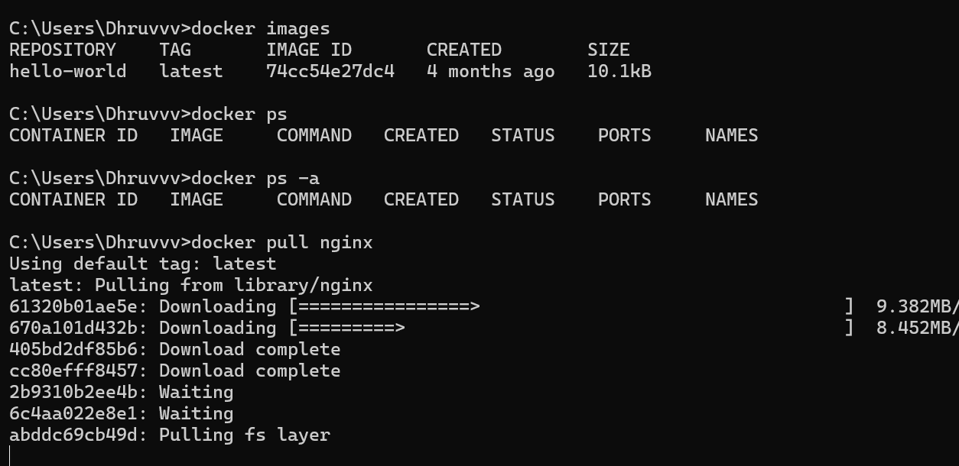

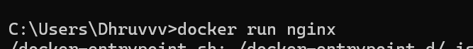



Volume

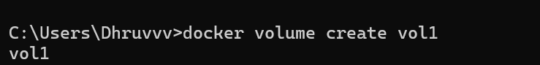

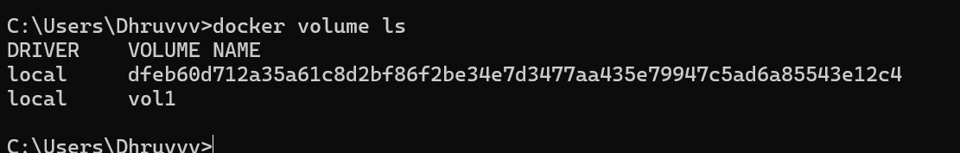

**Creating a container**

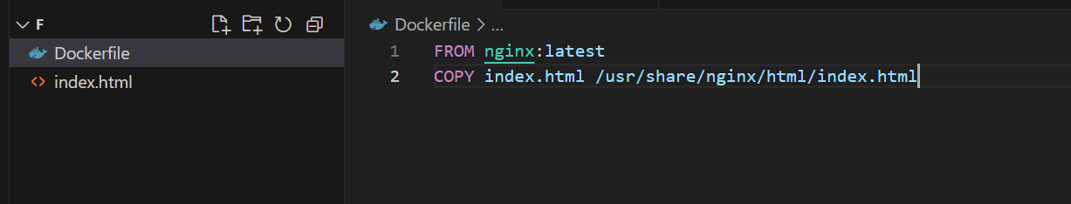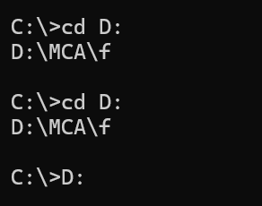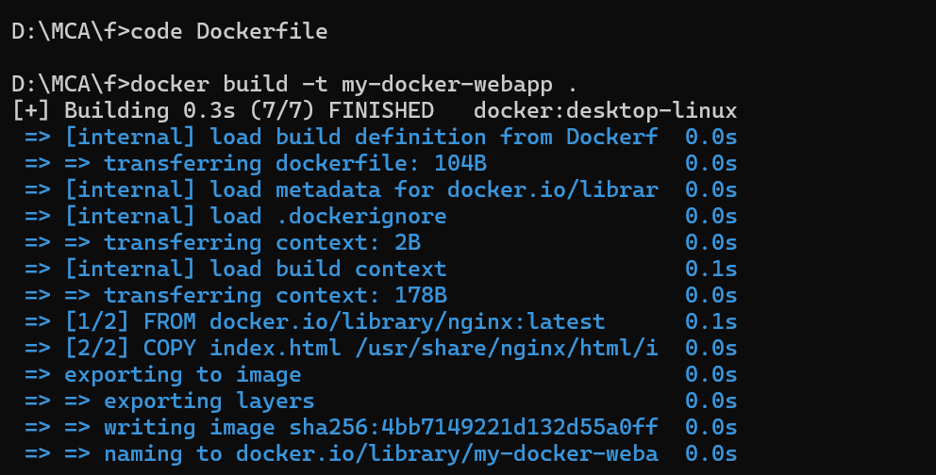

code Dockerfile

docker build -t my-docker-webapp .

docker ps

docker run -d -p 8081:80 -–name webapp-container my-docker-webapp

**Jenkins**

**pipeline {**

**agent any // Defines where the pipeline runs**

**stages {**

**stage('Build') { // Defines a step in the pipeline**

**steps {**

**echo 'Building the project...' // Print message to console**

**}**

**}**

**stage('Test') {**

**steps {**

**echo 'Running tests...'**

**}**

**}**

**stage('Deploy') {**

**steps {**

**echo 'Deploying the application...'**

**}**

**}**

**}**

**post {**

**success {**

**echo 'Pipeline completed successfully!' // Runs if the pipeline is successful**

**}**

**failure {**

**echo 'Pipeline failed!' // Runs if any stage fails**

**}**

**}**

**}**